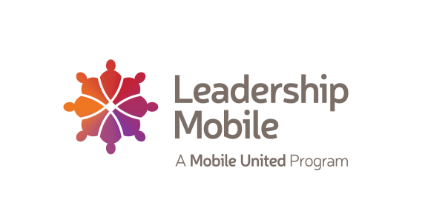
Nominations for the LEADERSHIP MOBILE Class of 2021 are now being accepted. If you are interested in nominating someone, or applying yourself, complete the enclosed Nomination Form and return it to the address indicated. Please make certain that the nomination form is complete and legible.

LEADERSHIP MOBILE seeks individuals:
* who represent a cross section of participants from business, the professions, education, organized labor, government, arts, clergy, service and community organizations, ethnic/minority groups and by gender
* who have demonstrated the capacity for leadership within their own organizations through significant achievements relative to age and experience
* who share a sincere commitment, motivation and interest in serving the greater Mobile community
* who have potential for advancement to top leadership positions within their own organizations which may result in significant influence over important issues facing the community
* who have demonstrated a commitment to community improvement through volunteer involvement
* who are able to make the time commitment necessary to complete the Leadership Mobile Development Program and has the full support of the corporation or organization he/she represents
* with the intention, upon completion of the program, to seek roles on community boards, commissions, key volunteer leadership positions, or public office and who will commit to join Leadership Mobile and Mobile United for two years after graduation
* who are committed to remain in the greater Mobile area or who are not likely to be transferred within the immediate future

The Selection Committee will choose a class that is representative of the diverse leadership needs of the community and will, in most cases, select only one representative from each business/organization per class. All nominees will be interviewed in June. All applicants will be notified in July 2020. The Class of 2021 will begin in mid-September. Those who are not selected for the class are invited and encouraged to re-apply in subsequent years.

Tuition for the Class of 2021 is $2,500. (tuition may be subject to change with notice). There are scholarship monies available to those who qualify.

The deadline for submitting a nomination is Friday, April 24th, 2020.

Class of 2021 Nomination Form
The mission of Leadership Mobile is to seek, train and empower leaders who are committed to supporting and leading community growth and progress through networking and collaborative problem solving. We are currently seeking candidates for our upcoming class. The deadline for submitting a nomination is Friday, April 24, 2020.
NOMINEE__________________________________________________________________________________
POSITION__________________________________________________________________________________
COMPANY/ORGANIZATION____________________________________________________________________
RESIDING CITY___________________________PHONE # ____________________________________________
NOMINEE’S EMAIL ADDRESS___________________________________________________________________
Leadership Mobile is committed to the selection of a class that is representative of the professional, racial, cultural, geographical and ethnic diversity of the community. Your response to the following is voluntary; however, it will assist in the recruiting phase during the nomination process. To find your district, please check here: http://maps.cityofmobile.org/myplace/myplace.html

RACE____________GENDER____________COUNTY DISTRICT____________CITY DISTRICT____________
RECOMMENDATION: No attachments please
__________________________________________________________________________________________
__________________________________________________________________________________________
__________________________________________________________________________________________
__________________________________________________________________________________________
NOMINATOR_______________________________________TELEPHONE_______________________________
I have contacted the above named nominee and he/she acknowledges this nomination:
SIGNATURE_____________________________________________ DATE ______________________________
Please return to Leadership Mobile Administrator Chris Gibson at cgibson@mobileunited.org or deliver to Leadership Mobile, P.O. Box 1243, Mobile, AL 36633 or 8 St. Joseph St., Mobile, AL 36602 Phone: 251-432-1638

